1. System Accessibility

- The system has already been deployed to internet and can be accessed via the url http://137.132.247.154/Dashboard/Q1.aspx

- The application web server and database server can be access via Remote Desktop using the following credential

  - Server IP : 137.132.247.154
  - User ID: se19team2s
  - Password: N@tional

- To connect to the database server via SQL Client (e.g. Toad or Oracle SQL Developer), use the following credential
  - Username: sys
  - Password: d
  - Role: sysdba
  - Hostname: 137.132.247.154
  - Port: 3306
  - SID: orcl

2. Whole System Deployment

Step 1: Deploy Web Application

- Create a virtual directory in IIS, alias as “dashboard”

- Link the visual directory to the application source code folder “WebApplication”, this folder can be found in part of this package @ %package% \Source&Script\WebApplication\CS5226

- Open DAO.vb file to change the connection string

  - @ %package% \Source&Script\WebApplication\CS5226\App_Code\DAO.vb

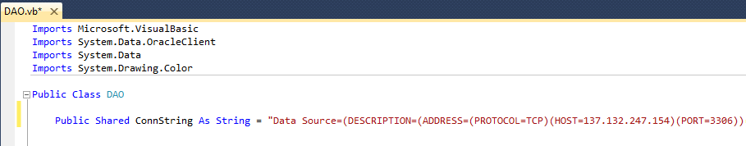

Step 2: Deploy Database Tables

Run the following Scripts which can be found @ %package% \Source&Script

# | Path and File Name | Description
1 | \DashboardSysDBScript\DDL.sql | This script is to create tables that will be used by the dashboard system
2 | \DashboardSysDBScript\DML.sql | This script is to load configuration data into dashboard system created in #1
3 | \DataLoadSimulationScript\DDL.sql | This script is to create data tables that will fold fabricated data
4 | \DataLoadSimulationScript\DML.sql | This script is to simulate large data loading (

Step 3: Deploy Scheduled Job

- Create a new schedule job via windows job scheduler
- Schedule a job that will run every 10 mins
- The schedule job will execute the following exe.
  - %package% \\Source&Script\CS5226Batch\CS5226Batch\bin\Debug\CS5226Batch.exe
- Change the exe source code to change the connection string
